
RAJALAKSHMI INSTITUTE OF TECHNOLOGY
(An Autonomous Institution, Affiliated to Anna University, Chennai)

DEPARTMENT OF CSE (ARTIFICIAL INTELLIGENCE AND MACHINE LEARNING)
ACADEMIC YEAR 2025 - 2026
SEMESTER IV
AL23421 - MACHINE LEARNING LABORATORY
MINI PROJECT REPORT

REGISTER NUMBER | 2117240030033
NAME | Girijan D
PROJECT TITLE | Feelio – A Mood Based Music Player
DATE OF SUBMISSION
FACULTY IN-CHARGE | Mrs. M. Divya

Signature of Faculty In-charge Signature of HoD

- INTRODUCTION
This project focuses on predicting a user’s mood and recommending suitable music using Machine Learning techniques. The system uses a Random Forest Classifier to analyze inputs such as sleep, energy, stress, social interaction, and positivity to determine the user’s emotional state. Based on the predicted mood, the application automatically selects and plays appropriate songs. Music plays a vital role in influencing human emotions, and choosing the right music at the right time can enhance overall well-being. This project aims to build an intelligent and interactive system that provides real-time mood-based music recommendations through a modern and user-friendly web interface.
- PROBLEM STATEMENT
To develop a machine learning-based system that predicts a user’s mood based on input parameters such as sleep, energy, stress, social interaction, and positivity levels. The goal of this project is to accurately identify the emotional state of the user and recommend suitable music in real-time. It aims to provide a seamless and interactive experience by automatically playing songs based on mood, incorporating a modern user interface, and enabling user feedback for continuous improvement. Additionally, the project focuses on achieving reliable prediction accuracy using ensemble learning techniques and delivering a user-friendly web application for intuitive interaction.
- THEORETICAL BACKGROUND

Random Forest is an ensemble learning algorithm that combines multiple decision trees to improve prediction accuracy and reduce overfitting. Instead of relying on a single model, Random Forest builds several decision trees during training and outputs the final prediction based on the aggregation of all trees.

Mathematical Representation

$$\hat{y}=\frac{1}{N}\sum_{i=1}^{N}{T_{i}}(x)$$

Where:
- $T_{i}(x)$= Prediction of the i-th decision tree
- $N$= Total number of trees
- $\hat{y}$= Final predicted output

Why Random Forest is Used
- Handles non-linear relationships effectively
- Reduces overfitting by averaging multiple trees
- Provides higher accuracy compared to single models
- Works well with structured datasets

Literature Survey:
    - Linear Regression (less accurate for complex data)
    - Decision Trees (prone to overfitting)
    - Gradient Boosting (complex but accurate)

Algorithm Explanation with Example
The Feelio system uses the Random Forest Classifier algorithm to predict the user’s mood based on emotional and behavioral inputs. Random Forest is an ensemble learning technique that combines multiple decision trees to produce accurate and stable predictions.
Instead of relying on a single decision tree, the algorithm constructs multiple trees using different subsets of the training data and features. Each tree independently predicts the mood, and the final output is determined based on the majority voting of all trees. This approach reduces overfitting and improves overall accuracy.
The prediction process followed in this project is explained below:

Step 1: Input User Data
- Sleep = 7
- Energy = 4
- Stress = 2
- Social = 4
- Positivity = 4
Step 2: Feature Representation
The input values are structured into a feature vector:
$$X=[7, 4,2,4,4]$$
Step 3: Data Processing
- Inputs are validated and normalized (if required)
- Converted into a format suitable for the trained model

Step 4: Model Input
The feature vector is passed to the trained Random Forest model:
$$\text{Model Input}=X$$
Step 5: Individual Tree Predictions
Each decision tree predicts a mood independently:
- Tree 1 → Happy
- Tree 2 → Happy
- Tree 3 → Relaxed
- Tree 4 → Happy
- Tree 5 → Happy
Step 6: Majority Voting
The final mood is determined by majority voting among all trees:
- Happy → 4 votes
- Relaxed → 1 vote
Step 7: Final Prediction
Final Predicted Mood = Happy
Step 8: Output Generation
Based on the predicted mood:
- A suitable song is selected from the “Happy” category
- Mood image and quote are displayed
- Music playback starts automatically

- IMPLEMENTATION CODE AND DATASET USED
  - Dataset Used – https://www.kaggle.com/datasets/mood-dataset/data
- Dataset Name: Mood Prediction Dataset (Synthetic)
- Domain: Emotion Recognition / Recommendation Systems
- Objective: Classification (Predicting User Mood)
- Data Type: Tabular
- Number of Samples: ~200
- Features (Inputs): Sleep, Energy, Stress, Social, Positivity
- Target Variable: Mood (Happy, Sad, Angry, Relaxed, Neutral)
- Data Source: Self-generated synthetic dataset
SAMPLE DATASET:
sleep,energy,stress,social,positivity,mood
7,4,2,4,4,Happy
5,2,4,2,2,Sad
5,3,5,2,1,Angry
8,4,1,4,5,Relaxed
6,3,3,3,3,Neutral
8,5,1,4,5,Happy
7,4,2,4,4,Happy
7,5,1,5,5,Happy
8,4,2,5,4,Happy
6,4,2,3,4,Happy
7,5,1,4,5,Happy
8,5,1,5,5,Happy
7,4,2,3,4,Happy
6,5,2,4,5,Happy
8,4,1,4,5,Happy
7,5,1,5,4,Happy
6,4,2,4,4,Happy

PYTHON CODE (CORE LOGIC):
from flask import Flask, request, jsonify
import pickle
import numpy as np
app = Flask(__name__)
model = pickle.load(open("models/mood_model.pkl", "rb"))
@app.route("/predict", methods=["POST"])
def predict():
data = request.json
features = np.array([[
data["sleep"],
data["energy"],
data["stress"],
data["social"],
data["positivity"]
]])
prediction = model.predict(features)[0]
return jsonify({"mood": prediction})
if __name__ == "__main__":
app.run(debug=True)

- OUTPUT:

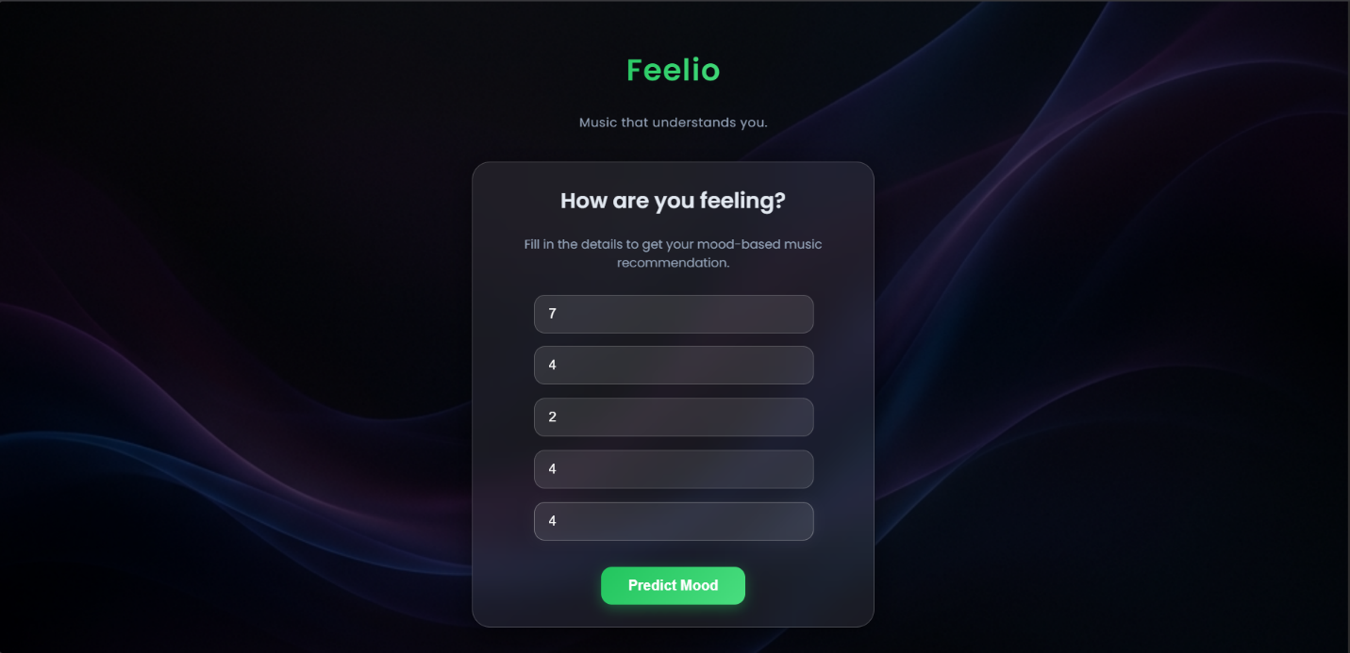
Description
This is the initial page where the user interacts with the system by providing inputs related to their current emotional and physical state.
Features
- Input fields for:
  - Sleep
  - Energy
  - Stress
  - Social Interaction
  - Positivity
- Clean glassmorphism UI design
- Background image with blur effect
- Smooth animations and transitions
- Submit button to send data
Functionality
- Collects user data
- Sends input to backend (/predict API)
- Triggers mood prediction process

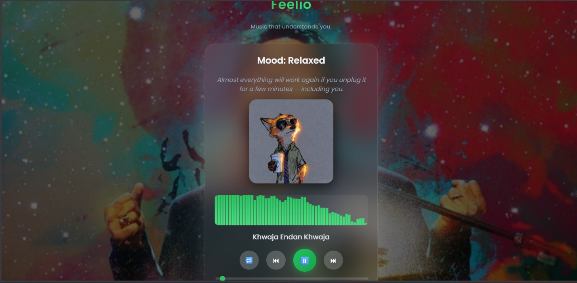
Description
This page is displayed after mood prediction. It shows the predicted mood and plays music accordingly.
Features
- Displays:
  - Predicted Mood
  - Mood-based Quote
  - Dynamic Image
- Custom music player UI
  - Play / Pause / Next controls
  - Stylish progress bar
- Auto-play functionality
- Auto next song playback
- Background image (fixed, non-random)
- Audio visualizer (real-time animation)
Functionality
- Receives prediction result from backend
- Selects song from corresponding mood folder
- Plays music automatically
- Updates UI dynamically


Description
This section allows users to provide feedback on the recommended music.
Features
- 👍 Like button
- 👎 Dislike button
- Simple and intuitive UI
Functionality
- Stores feedback in:
feedback/feedback.json
- Helps improve system understanding (future scope: adaptive learning)
4. Background & Visual Experience Layer
Description
This is not a separate page but a visual layer that enhances the overall experience.
Features
- Dark gradient background
- Glassmorphism cards
- Vibrant accent colors
- Smooth transitions between states
- Fixed background for song page
Functionality
- Improves user engagement
- Provides a professional, modern look

- Results & Future Enhancements:

➤ Results
- The model provides accurate mood predictions based on user inputs
- Real-time prediction is achieved through the Flask web interface
- The system successfully integrates Machine Learning with a dynamic UI
- Music is automatically played based on predicted mood
- The application offers a user-friendly and interactive experience
- Performance is evaluated using classification metrics:
  - Accuracy
  - Precision
  - Recall
  - F1-Score
➤ Future Enhancements
- Use real-world psychological datasets instead of synthetic data
- Integrate deep learning models for improved prediction accuracy
- Enhance personalization using user listening history
- Deploy the system as a mobile application
- Add voice-based mood detection
- Implement adaptive learning using user feedback
- Integrate with music APIs (e.g., Spotify) for real-time streaming

Git Hub Link of the project along with the report | https://github.com/Giri6126/Mood-to-Music-Player
- REFERENCES

  - • Scikit-learn Documentation – Random Forest Classifier
https://scikit-learn.org/stable/modules/generated/sklearn.ensemble.RandomForestClassifier.html
  - • GeeksforGeeks – Random Forest Classification
https://www.geeksforgeeks.org/random-forest-classification-in-python/
  - • Random Forest Research Paper (Leo Breiman, 2001)
https://link.springer.com/article/10.1023/A:1010933404324
  - • Flask Official Documentation
https://flask.palletsprojects.com/
  - • Python Documentation
https://docs.python.org/3/

